I started by creating the slice for the experiment on fabric.
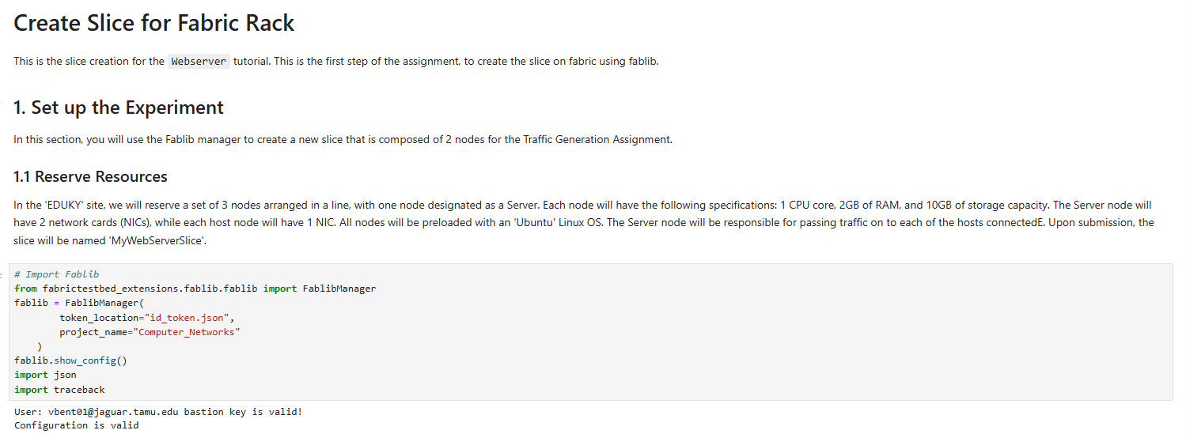
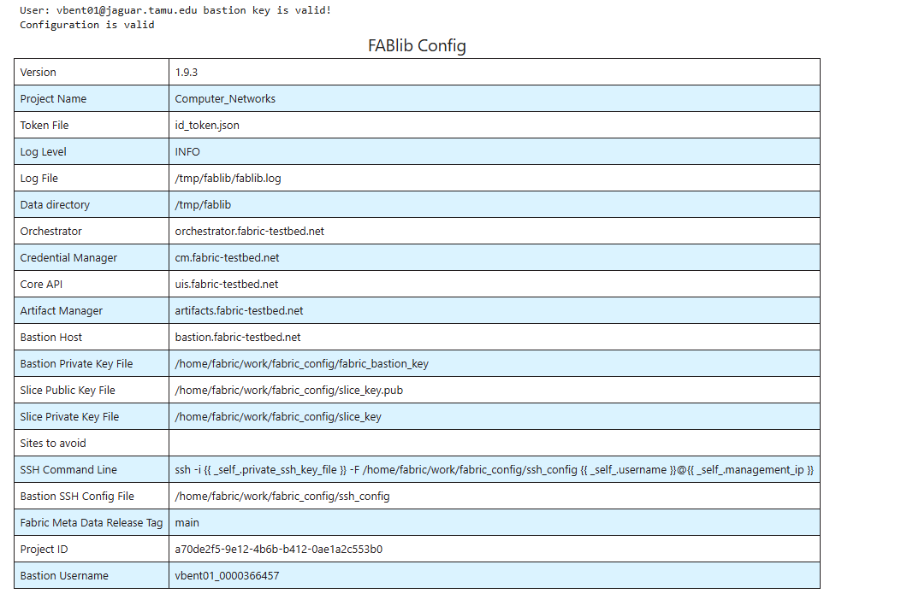
Then I gave slice details,
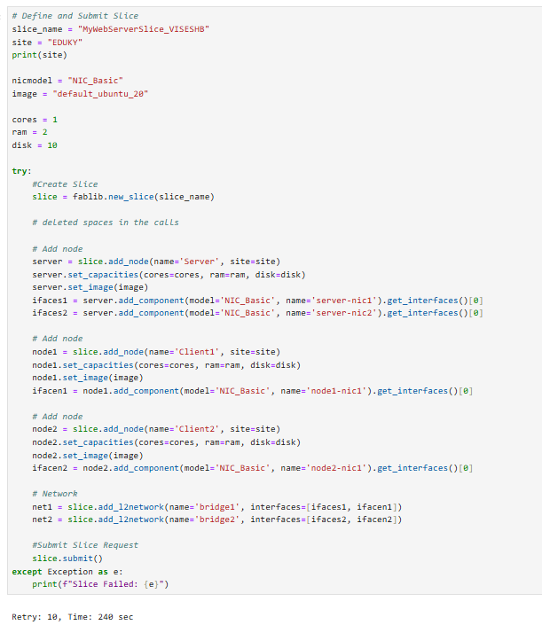
You can see below the slice is created successfully.

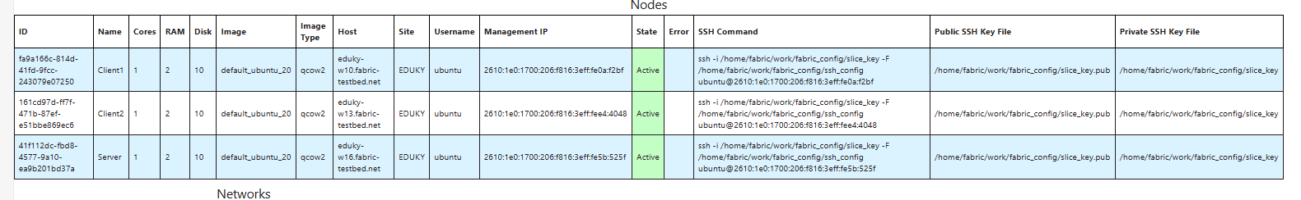
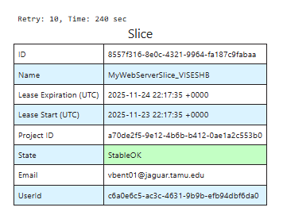

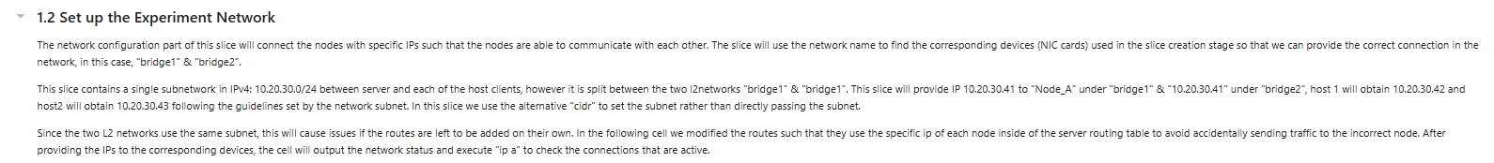
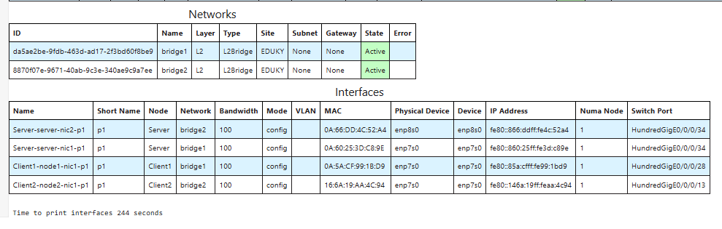
Now we set up the Experiment network

We setup network
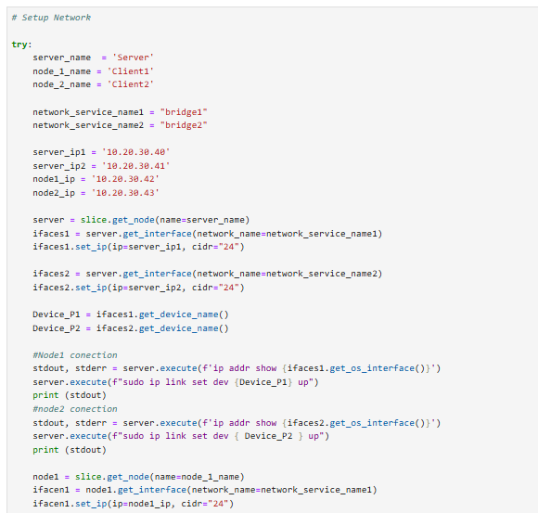

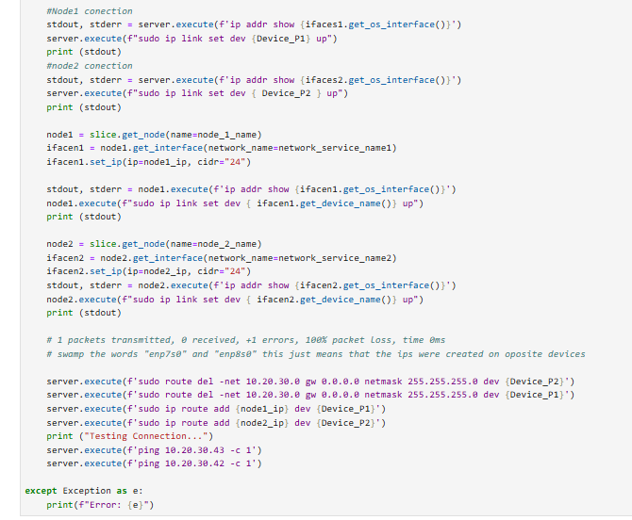
The network has been setup successfully.
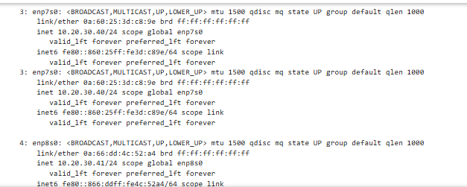
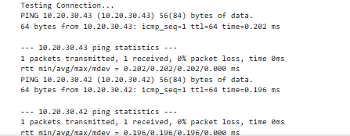
Now we configure the software needed for the nodes in the experiment
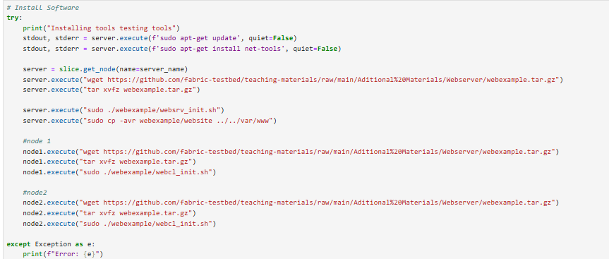

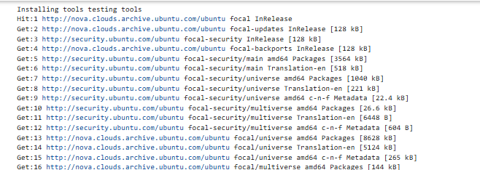
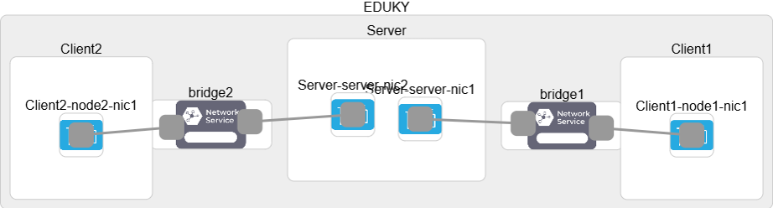
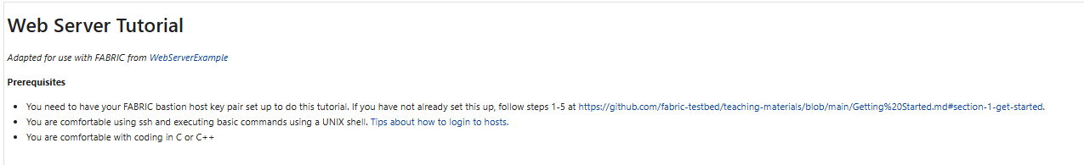
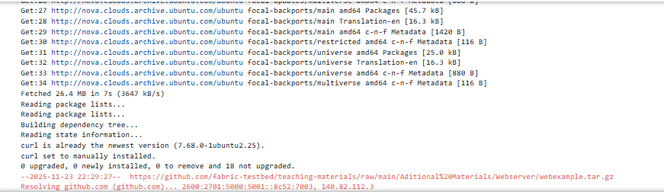
This is the slice I created for the Experiment
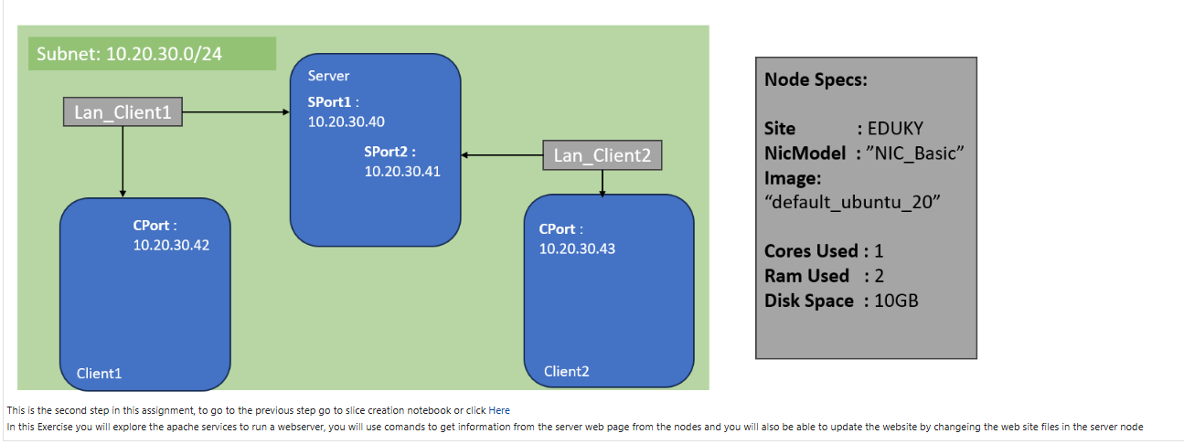
Now we retrieve the slice because we are doing the experiment in a different notebook
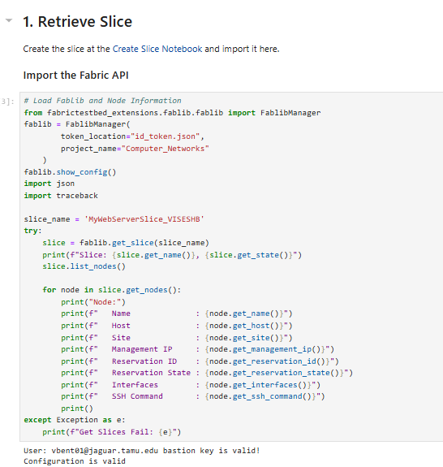
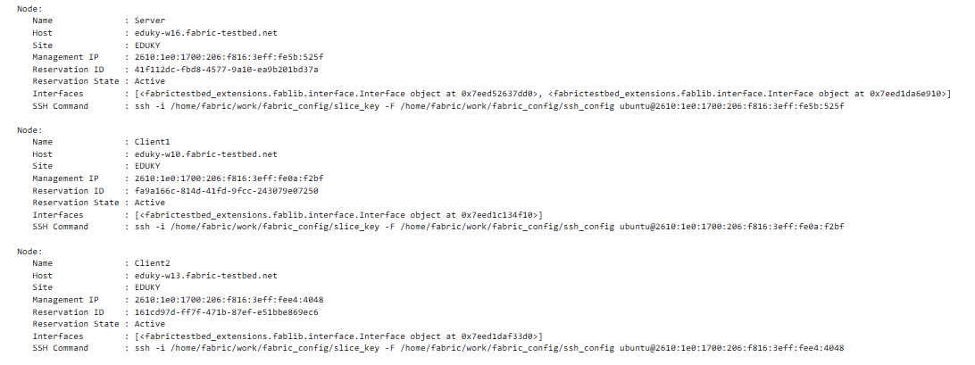
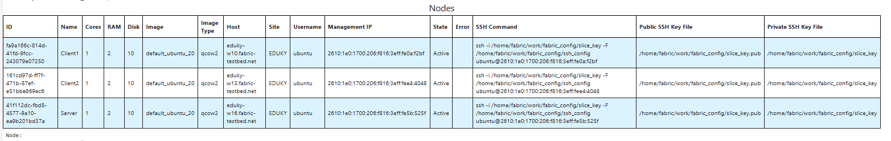
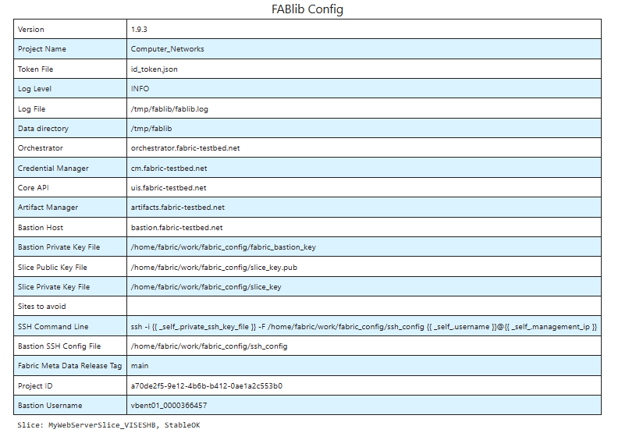
One we retrieved the slice we start the experiment as per the instructions
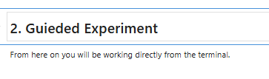
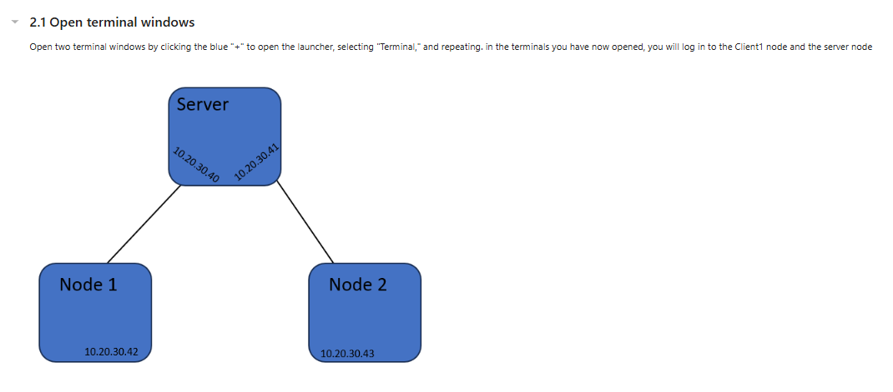
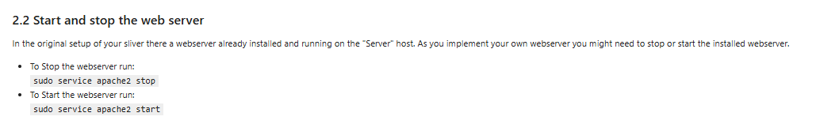
I logged in server node
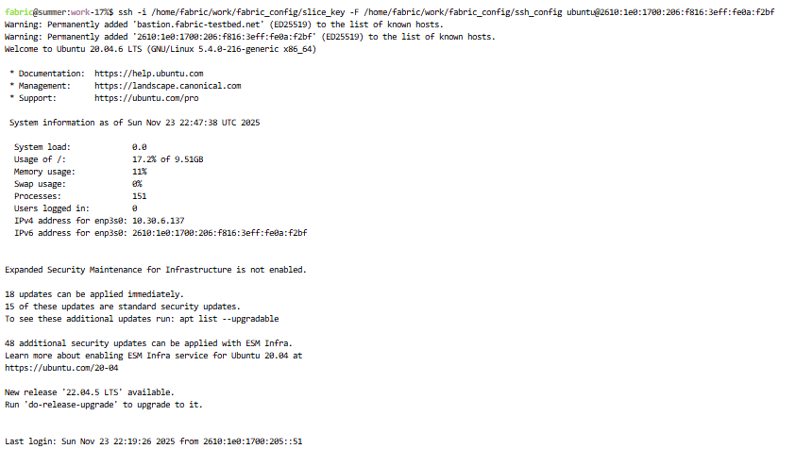
Then followed instructions as per the manual.
2.3 Command Line Web Transfers¶
Instead of using a web browser, you can also use command line tools for web transfers. To do this, follow these steps:
- Log in to Client1
- You can download the web page using this command, in this example, the address for the server will be the IP address:
wget 10.20.30.40
- The above command only downloads the index.html file from the webserver. As we are going to see later a web page may include other web pages or objects such as images, videos etc. In order to force wget to download all dependencies of a page use the following options:
wget -m -p 10.20.30.40
- This will produce a '10.20.30.40', server, with the following data structure. Run:
ls 10.20.30.40
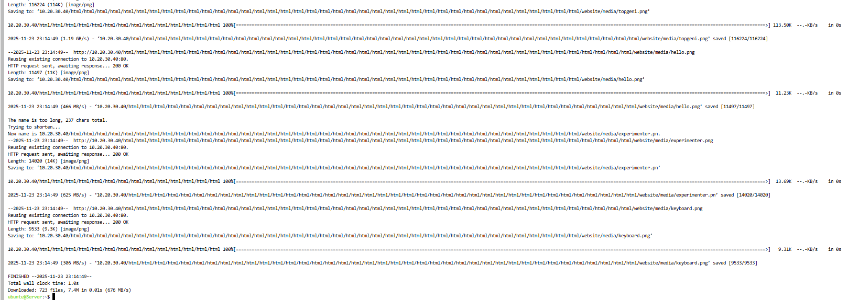

2.4 Build your own Server
- At a high level, a web server listens for connections on a socket (bound to a specific port on a host machine). Clients connect to this socket and use a simple text-based protocol to retrieve files from the server. For example, you might try the following command on Client1:
% telnet server 80
GET /index.html HTTP/1.0
(Type two carriage returns after the "GET" command). This will return to you (on the command line) the HTML representing the "front page" of the web server that is running on the Server host.)
In our setup we are using the Apache web server. The default document root for Apache on a host running Ubuntu is under /var/www.
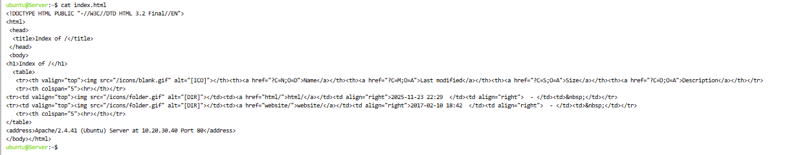
- Login to the Server host and run:
ls /var/www/ This should give you a similar structure to the directory structure you got when you downloaded the whole site with wget on the previous steps.

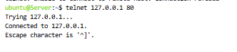

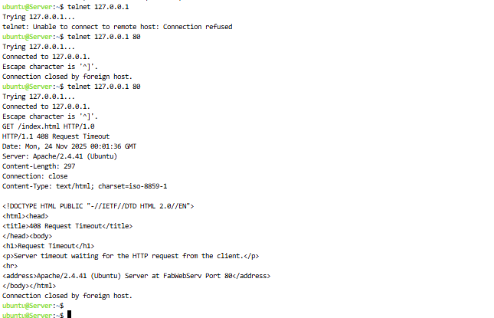
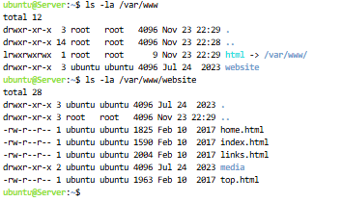
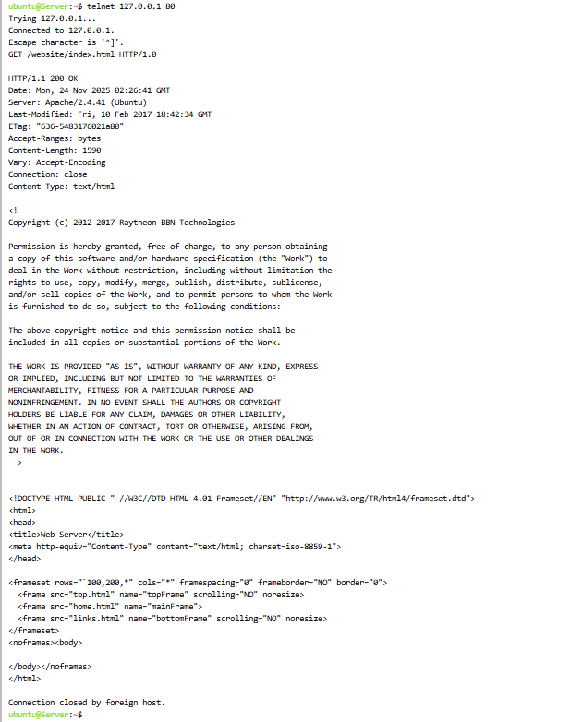
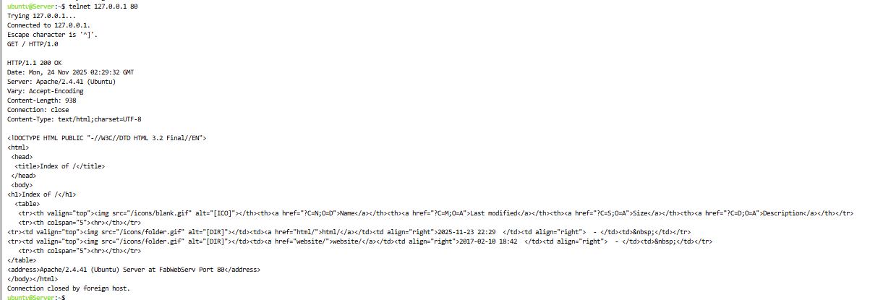
3. Assignment
3.1 Creating HTML:
Create your own correctly formatted HTML document in place of the message in index.html. Follow the same procedure as above to retrieve this document. For those completing this module for credit, submit a screenshot of the output on the client machine.

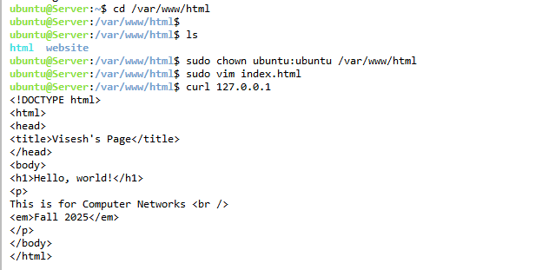

3.2 Response Codes
You’ve learned that HTTP has many different status codes. By modifying your requests made from the client machine, generate 4 different status responses from the server. For those completing this module for credit, submit the requests you made to generate each response along with an explanation of why each response was sent by the server.
3.2.1 200 OK
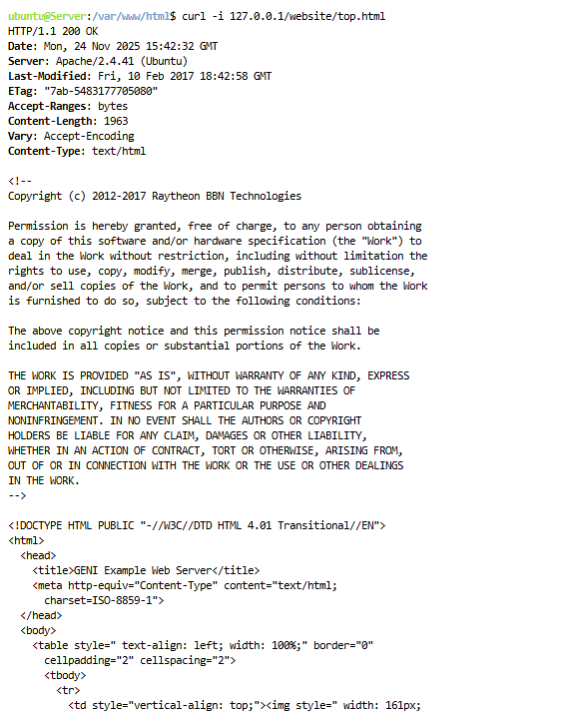
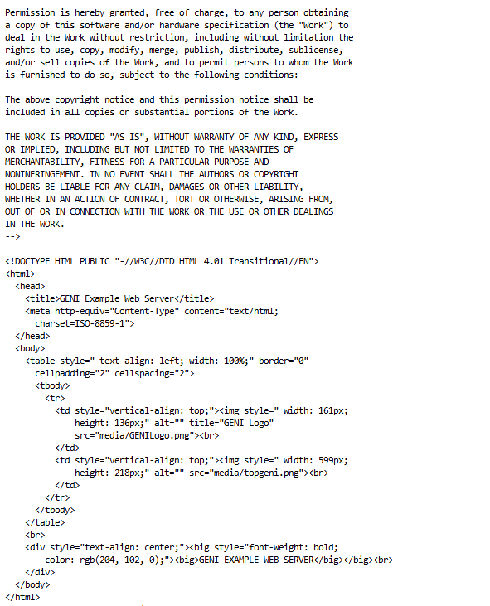

3.2.2 404 Not Found
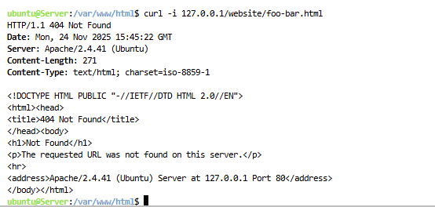
3.2.3 301 Moved Permanently
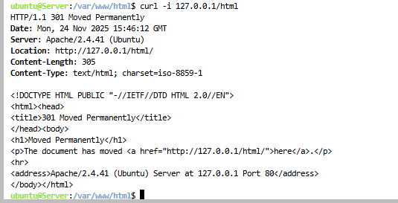
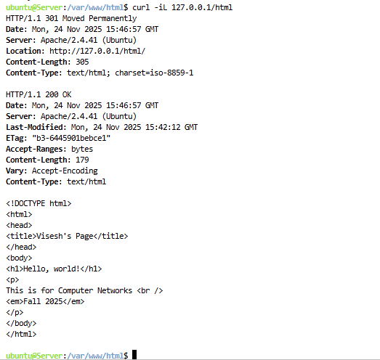
3.2.4 405 Method Not Allowed
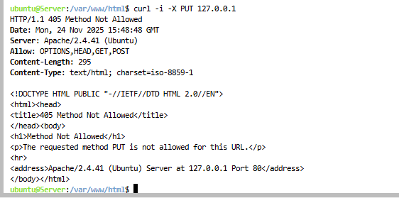

After successfully finishing all the steps I cleaned up the resources.

